1. Name and Purpose of the Agent
BalanceBot is an RL bot that was trained in the CartPole-v1 environment. The game is actually pretty simple. The bot just needs to balance the pole on the moving cart. Every time it makes a move, it tries to move the cart left or right to counter the tilt of the pole.
It’s learning in the usual RL way: experimenting, getting rewarded when it’s balanced, etc. Nobody taught it the “right” way to balance the pole before.

2. Algorithms Used
This project uses tabular Q-learning, which is an off-policy method and a type of temporal difference learning. The agent learns the score of each state-action pair, denoted by Q(s, a). The agent improves the score using the following formula:
Q(s, a) ← Q(s, a) + α[r + γ max_a′ Q(s′, a′) - Q(s, a)]
where α is the size of the step taken in the value function during learning, and γ is the factor determining the importance of the rewards received in the future.
However, the observations in the CartPole environment are continuous, and tabular Q-learning requires discrete states. The agent discretizes the range of the four observations and uses the discretized positions to create a state ID. This transforms the continuous space into a discrete space that the agent can learn from using the Q-table.

3. Environment, Dataset Information, and Preprocessing
3.1 Dataset source/link
This project is implemented by utilizing the Gymnasium library, which has a built-in environment called CartPole-v1. Rather than being trained on a set dataset, this agent generates its own training data by repeatedly interacting with the environment.

3.2 Number of records
Each "record" is one step of experience, i.e., (s, a, r, s′, done). The number depends on how long you train. For example, if you train for 1,500 episodes with an average of 200 steps per episode, that's about 300,000 transition records.
3.3 Number of features
You're given four continuous values each step by the environment. Then each of these continuous values gets replaced by a corresponding bin number, which is an integer. Collectively, these four integers represent the agent's single discrete "state."
3.4 Description of features

Feature | Description | Data Type
cart_position | Horizontal position of the cart | float
cart_velocity | Velocity of the cart | float
pole_angle | Angle of the pole from vertical | float
pole_angular_velocity | Angular velocity of the pole | float
action | 0=push left, 1=push right | int
reward | Reward per step (+1 each step) | float

3.5 Preprocessing steps

As part of the preprocessing, the four continuous observation values are snapped into their respective bins with np.digitize. This results in four bin numbers, which are then packed into one single state ID with np.ravel_multi_index.
After all of this has been converted to discrete states, the agent can learn with a simple Q table, just storing and updating values as it trains.

4. Libraries, Toolkits, and Frameworks
Gymnasium manages the simulation and provides the RL interface. NumPy stores the Q table in memory and updates it during training. Matplotlib is used to plot learning curves, allowing you to visualize the improvement of the agent. All code is packaged as a command-line script.
5. Application Design and Implementation
This is done by training the agent by the following process: “Reset the environment, select actions using ε-greedy, perform an action, update Q(s,a) using the TD target, and track the reward.” As the training progresses, the value of ε is reduced to change the agent’s policy from “trying random stuff” to “using what it learned.”
Once this is done, the agent is then evaluated using a greedy policy, and the results are written to the “outputs” folder. The results include the learning curve, Q table, and JSON object.
6. Instructions for Running the Agent
1) Install Python 3.10–3.12.
2) Create a virtual environment and run: `pip install -r requirements.txt`.
3) Train: `python rl_cartpole_qlearning.py --episodes 1500`.
4) Check `outputs/learning_curve.png` and `outputs/run_summary.json`.clea

7. Results
As the agent gets better during training, you'll also see the learning curve as the episode rewards rise over time. Additionally, a JSON file containing the evaluation results is produced by the script.
Image 1. Training console output.
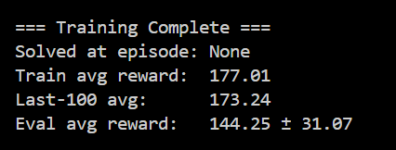
Image 2. Learning curve.
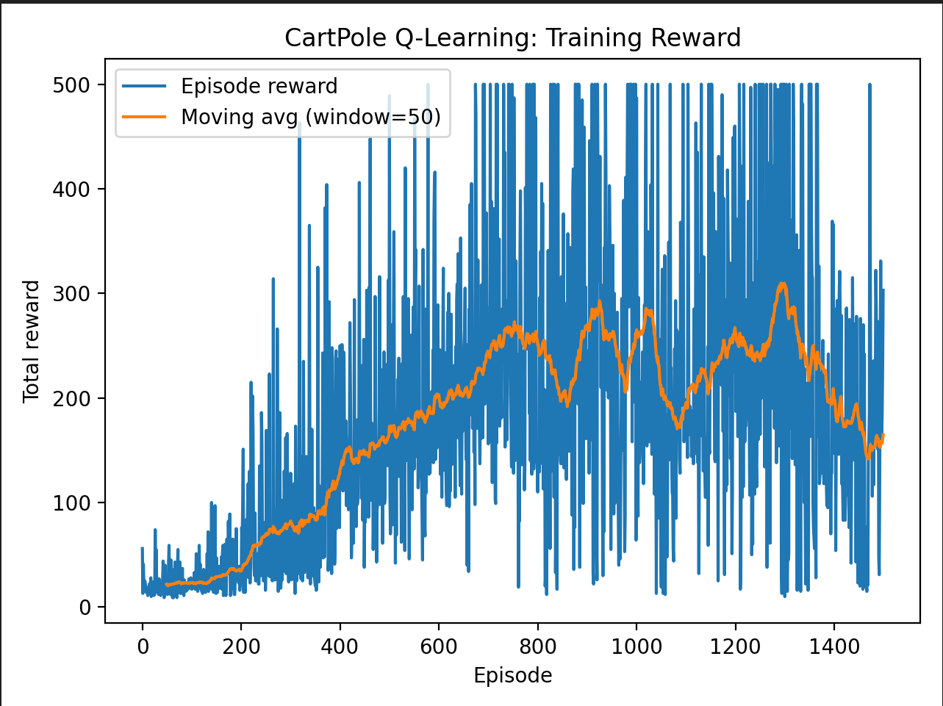
8. Discussion and Insights

If the tabular Q-learning is well configured, it is possible to solve the problem of the CartPole. However, the results will entirely depend on the configuration of the discretization, learning rate, and exploration strategy. This is because, if the discretization is not sufficient, the model may not be able to grasp the details. Conversely, too many discretizations may cause the learning process to take a long time because the process does not often repeat the same state.

A DQN model that is capable of learning directly from the observations without the need for discretization is then used after the parameters of the model have been adjusted and tested using various random seeds to ensure the accuracy of the results.

9. References
Farama Foundation. (n.d.). Gymnasium documentation. https://gymnasium.farama.org/
Sutton, R. S., & Barto, A. G. (2018). Reinforcement learning: An introduction (2nd ed.). MIT Press.
Watkins, C. J. C. H., & Dayan, P. (1992). Q-learning. Machine Learning, 8, 279–292. https://doi.org/10.1007/BF00992698

